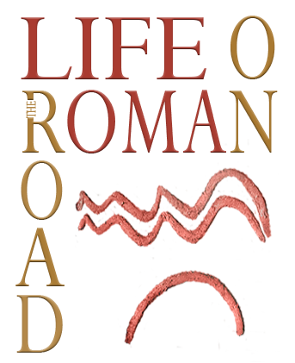

Application form

„Eating and drinking along ancient roads and rivers: Study opportunities, archaeological sources and open issues about diet habits”
Roads and rivers 3
11th to 12th November 2021

First author/contact author

Name, surname ______________________________________________________
Email ______________________________________________________________
Institution, address _____________________________________________________

Coauthor (add as many as needed)

Name, surname ______________________________________________________
Email ______________________________________________________________
Institution, address _____________________________________________________

Please state if there are special dietary requirements (vegetarian, vegan, allergies ...)

Title of paper:

___________________________________________________________________

Abstract (400 words)

